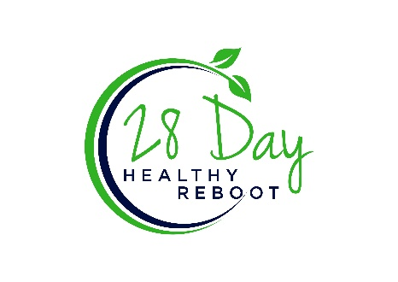

Clean Vegetable Soup

3 tablespoons avocado or coconut oil

2 cloves of garlic, chopped but not finely

3 or 4 scallions greens only or 3 leeks greens only

2 pounds broccoli or other vegetables\* (approx.) washed and cut into about 3-inch pieces

Fresh grated ginger, about 1 tsp

Thyme, basil, rosemary, or any combination – to taste, about 1 tablespoon, fresh or dry

3 ½ to 4 cups filtered water

Salt and pepper to taste

Heat skillet with oil of choice and gently sauté garlic for about 1-2 minutes, remove garlic pieces (garlic pieces are a FODMAP and eliminated days 8-28). Add in either leeks or scallions (No bulbs, also FODMAPs) and sauté for another 3-4 minutes until tender. Add remaining ingredients, heat water to boiling, cover and lower to simmer until broccoli/veggies\* is tender, between 10-12 minutes.

Once broccoli/veggies\* are cooked to tender, transfer to a blender of Vitamix and blend until smooth.

Optional – You can add a little coconut milk to make it creamy. Reduce water in recipe and add half a can of full fat coconut milk when blending.

\*Watch vegetable choices on days 8-29. Stick with your shopping guidelines!